Module 3: Critical Thinking Assignment

Student: Nathan Rogers

Date: 9/1/2024

**Abstract:** This assignment consists of two parts; Part1 and Part 2. Part 1 asks for the meal total at a restaurant and to automatically add sales tax and gratuity to then output the grand total of the meal. Part 2 asks for the current time on the 24-hour clock along with how many hours to set an alarm for. The final result should be the hour on the 24-hour clock the alarm goes off.

**Part 1: Meal total**

**Pseudocode:**

Take the user input for the meal_total variable

print sales_tax is 7% and the gratuity/tip is 18%

Add the meal_total to include 7% sales tax and an 18% tip

print total result

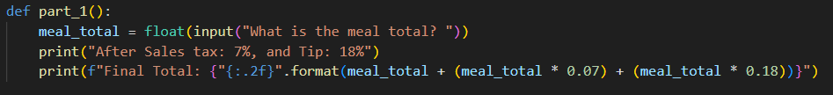

This section takes an input, casts it as a float as totals will always include at least two decimal places and then calculates what the final total would be with the sales tax and gratuity included and formats the output to include only two decimal places.

**Part 2: 24-hour clock alarm**

**Pseudocode:**

Take the current 24 hour time as a user input

Take the amount of hours to set the alarm for also as a user input

Take current_time + alarm_hours mod 24 to find alarm_time

Print alarm_time

This section takes an integer input for the current_time along with how many hours you want the alarm to be set for. To find the time the alarm will go off, a simple modulus 24 will leave the final result. An extension to this problem could also be to print out in the 12 hour am/pm clock format too.

**GitHub Link: https://github.com/NTPRuntime/Masters-Programs**